Eagle Eye Network Integration Guideline for GCX-ONE

1. Overview
This document describes the required client-side configuration and GCX-ONE-side onboarding steps to integrate Eagle Eye Networks with the GCX-ONE platform.
The integration uses Eagle Eye Bridge identifiers to discover securely and register devices in GCX-ONE.

2. Client-Side Configuration (Eagle Eye)

2.1 Bridge Settings
This section provides hardware, network, and identification details of the selected Eagle Eye Bridge. These parameters are required for validation and onboarding in GCX-ONE.
Parameter | Description
SSN (System Serial Number) | Unique serial number assigned to the Eagle Eye Bridge hardware.
IP Address | Local IP address assigned to the bridge within the internal (LAN) network.
ESN (Equipment Serial Number) | Mandatory identifier required to add the device into GCX-ONE.
GUID (Global Unique Identifier) | Cloud-level unique identifier used by Eagle Eye to identify the device globally.
WAN | 1000 Mb/s – Uplink interface supporting Gigabit Ethernet connectivity.
CamLAN | 1000 Mb/s – Camera LAN interface supporting high-throughput camera traffic.
CamLAN+ | Confirms support for up to 1000 Mb/s, enabling multiple high-resolution camera streams without congestion.
Important:
Ensure the bridge has stable WAN connectivity and is successfully registered in the Eagle Eye Cloud before proceeding with GCX-ONE onboarding.
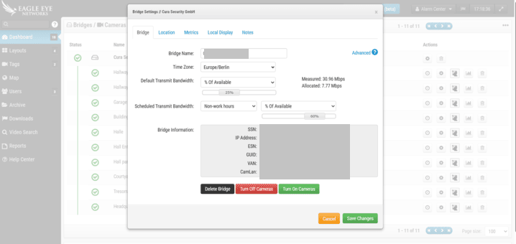

2.2 User Settings (Eagle Eye Cloud)
The following user-level settings must be validated before integration:
- A valid Eagle Eye Cloud user account with administrative privileges at the reseller level or customer level.
- Permission to:
  - View bridge details (ESN, GUID).
  - Manage devices and camera assignments.
- The bridge must be in an Online / Connected state.
- Time synchronization (NTP recommended) must be enabled on the bridge.
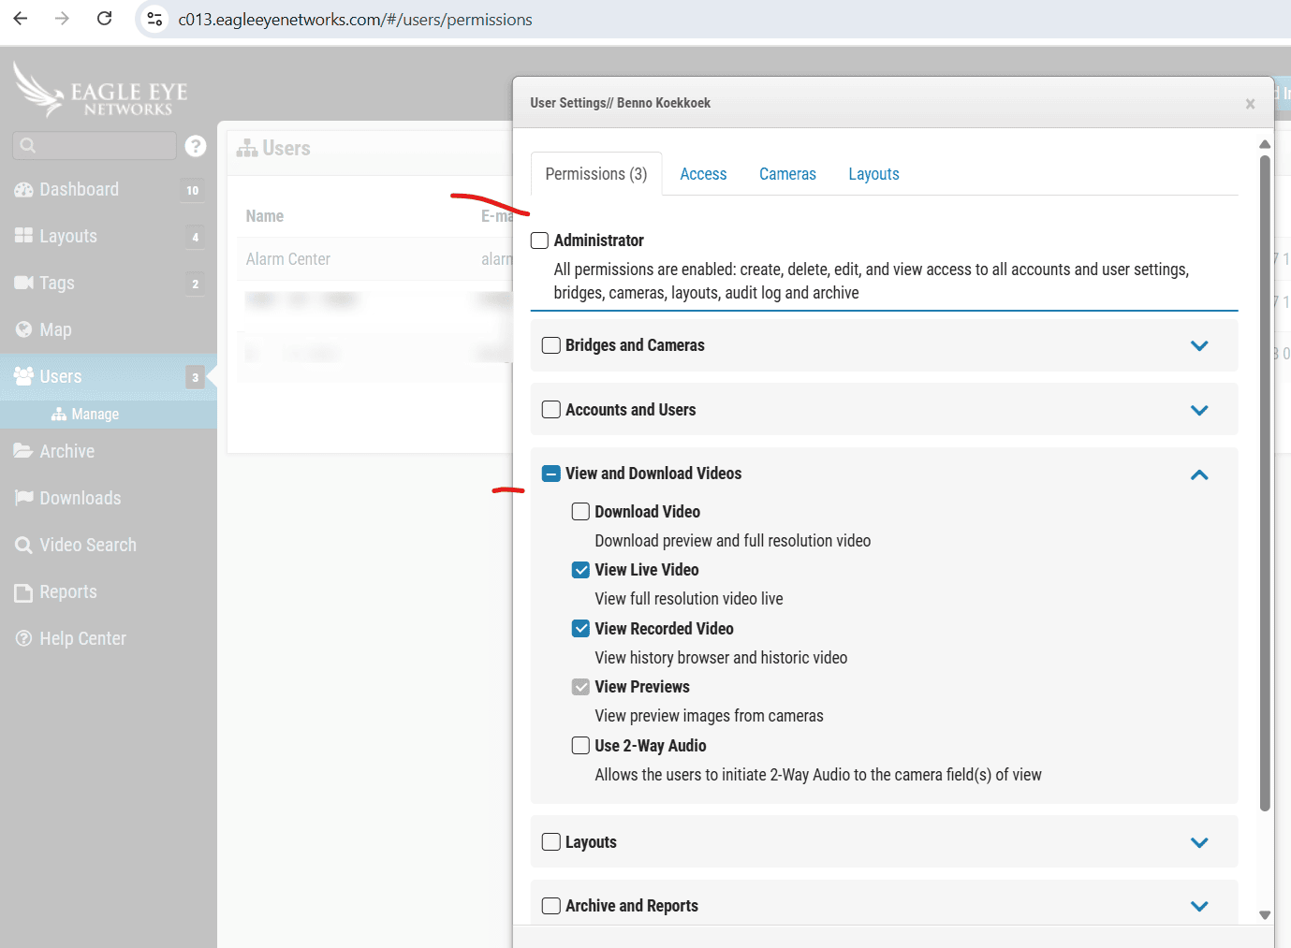
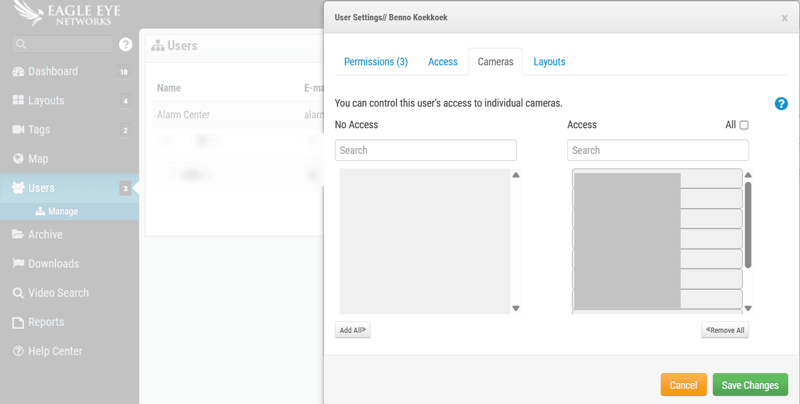

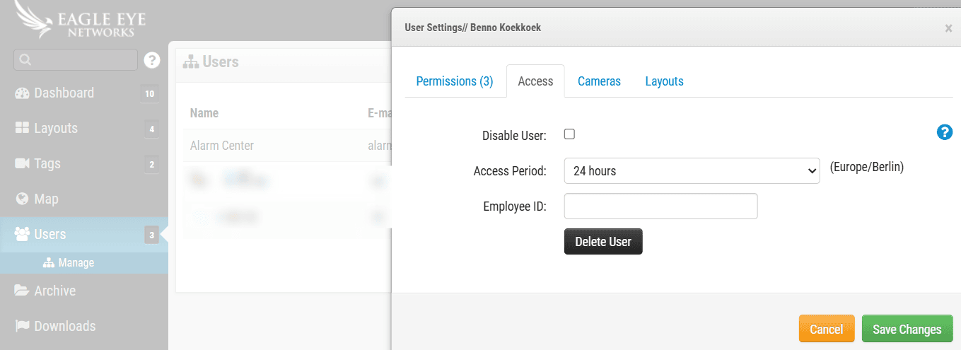

3. GCX-ONE Configuration Steps

Step 1: Log in to GCX-ONE.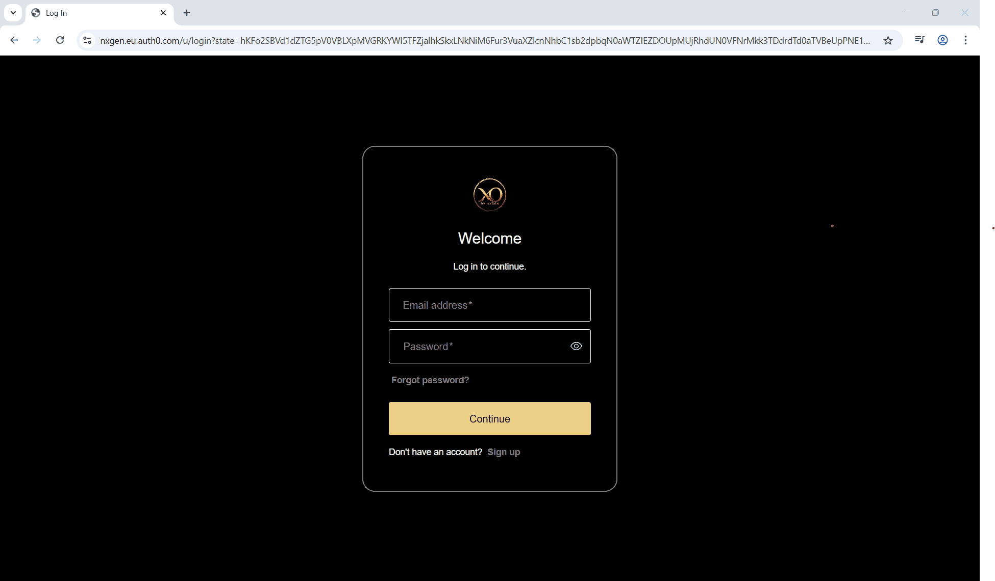
Step 2: Click on the Configuration menu.
Step 3: At the Service Provider level, click on Customers.
Step 4: Click the Add button.
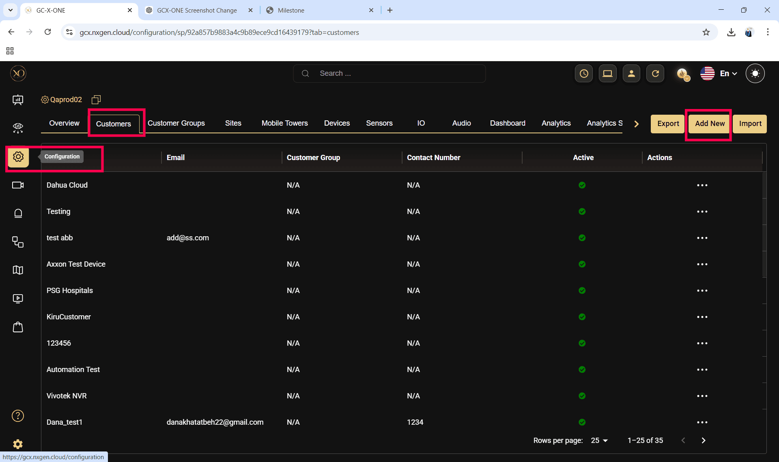

Step 5: Enter the required fields and click Save.
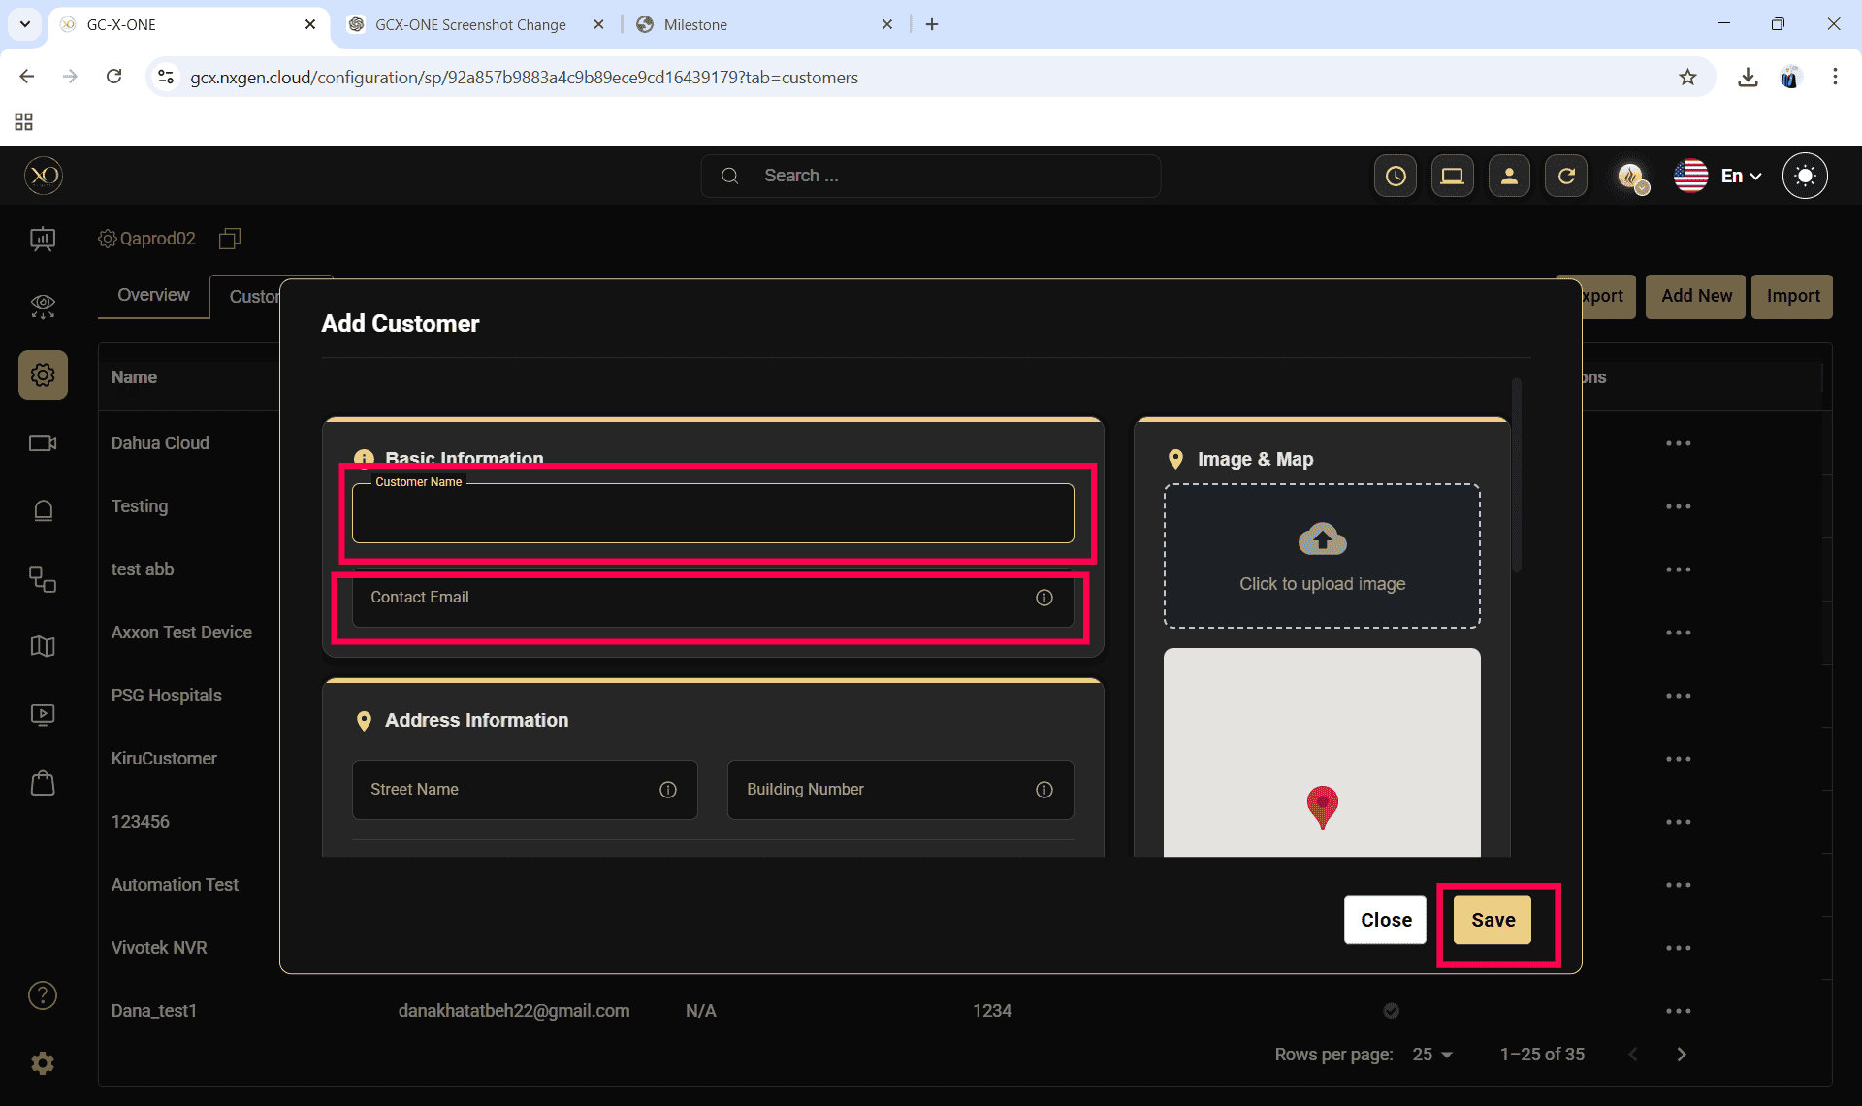

Step 6: Select the newly created customer.
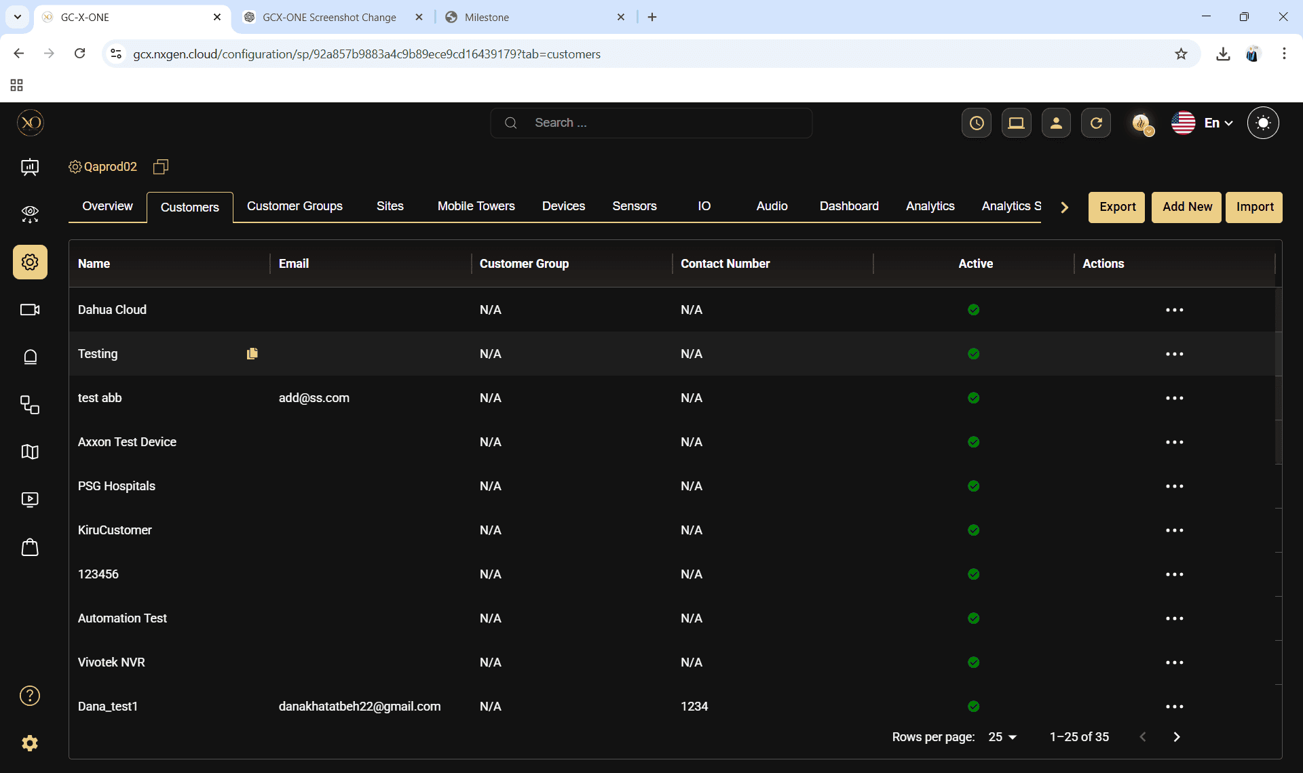
Step 7: Navigate to the Sites tab.
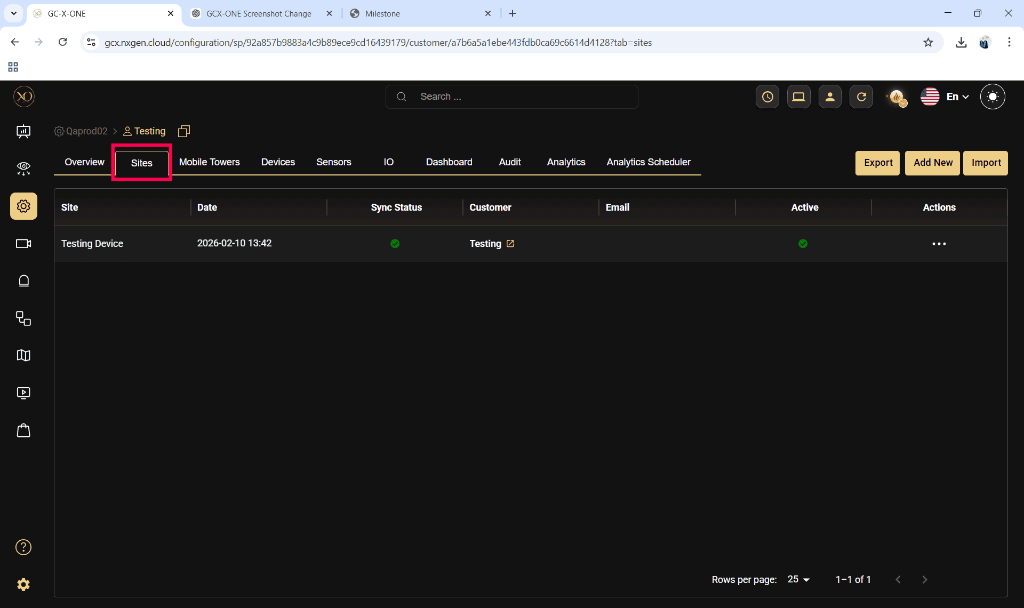

Step 8: Click the Add button.
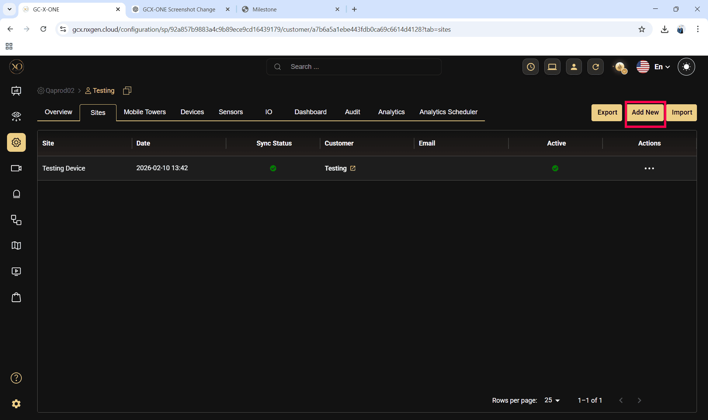
Step 9: Enter the required fields and click Save.
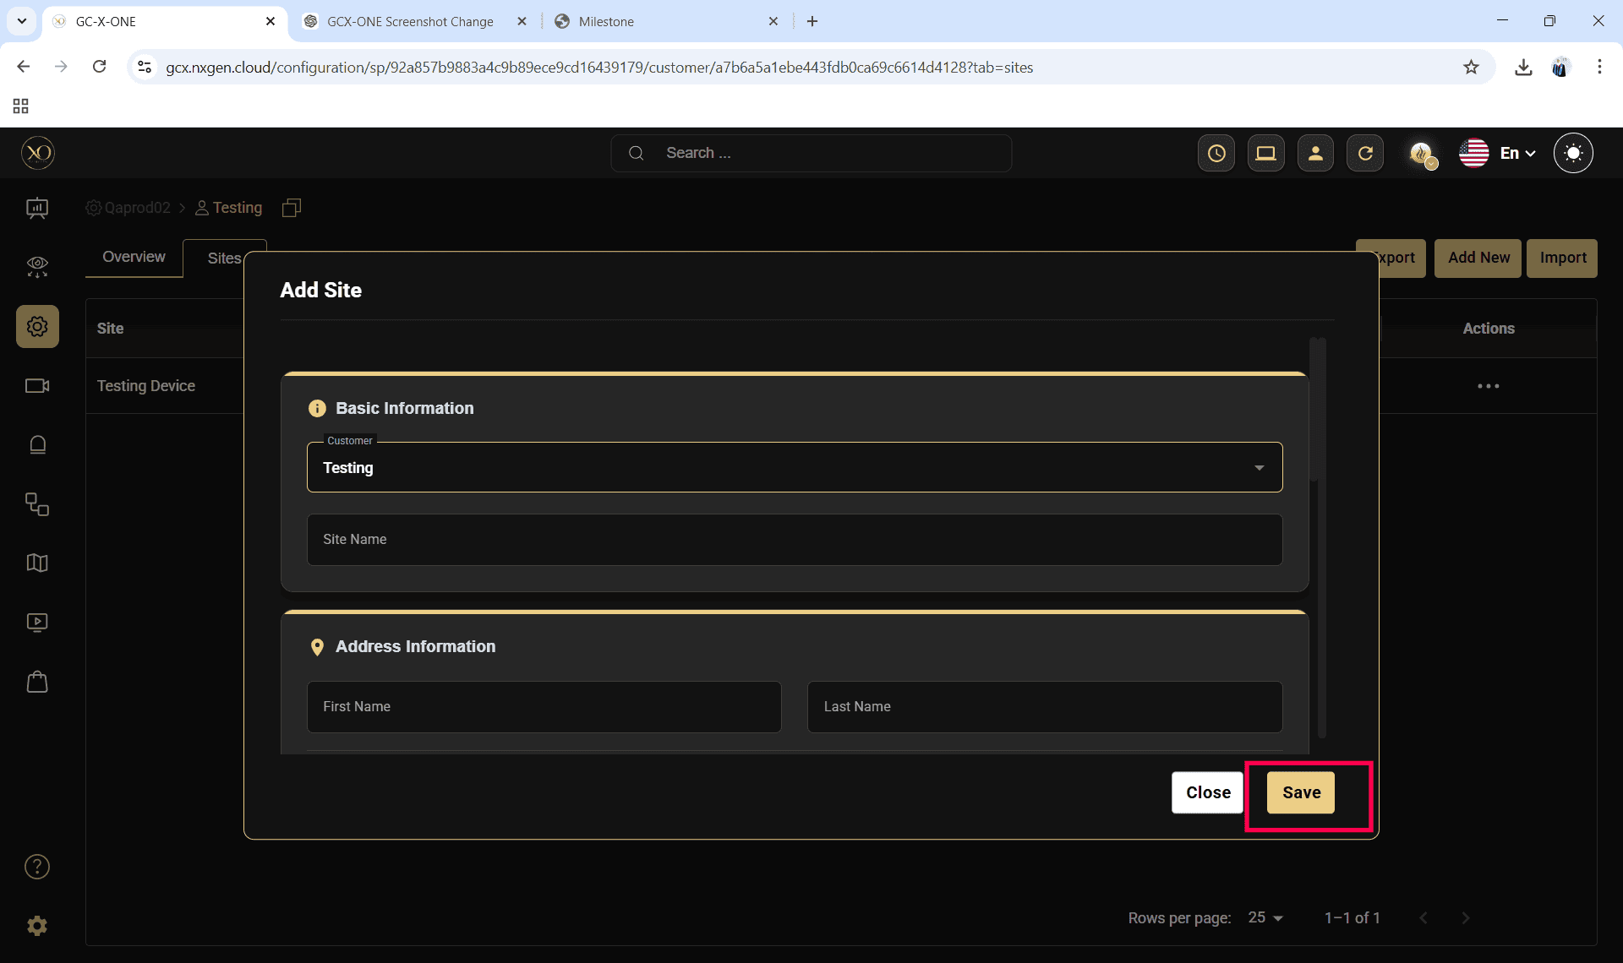

Step 10: Select the newly created site.
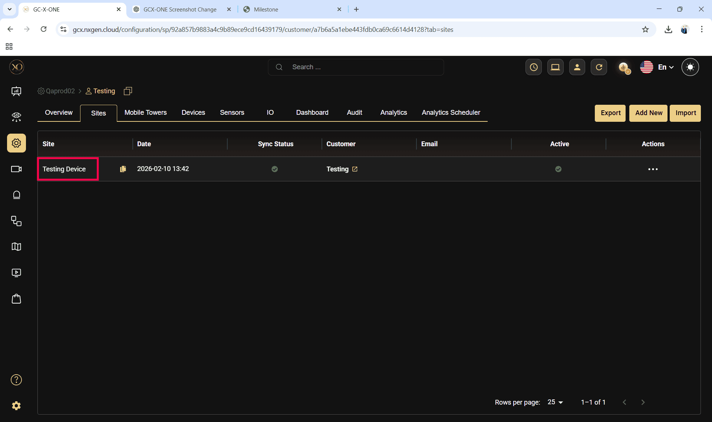
Step 11: Navigate to the Devices tab.
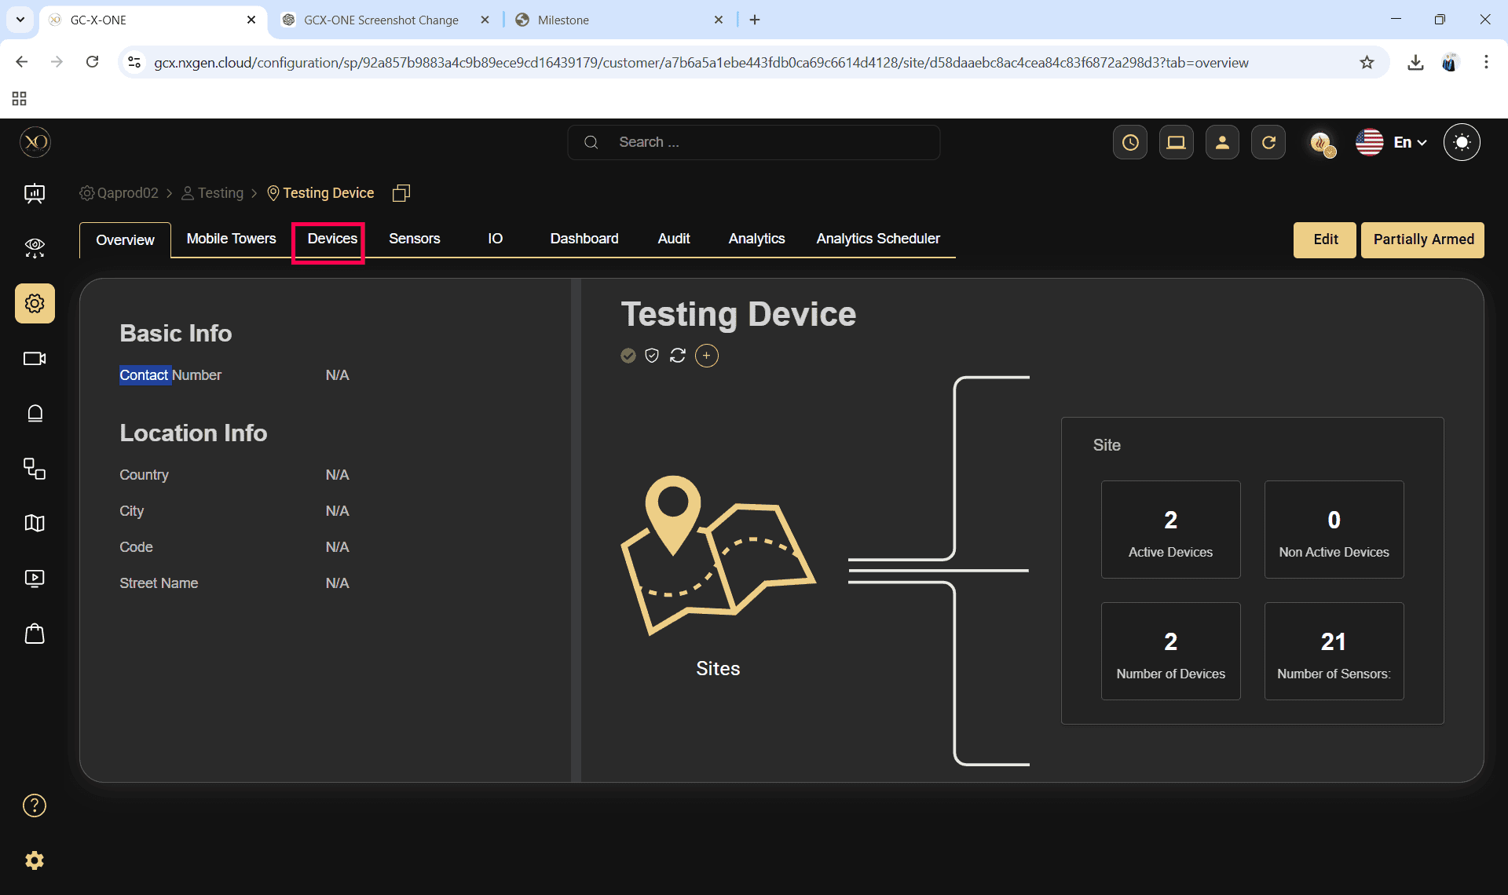

Step 12: Click the Add button.
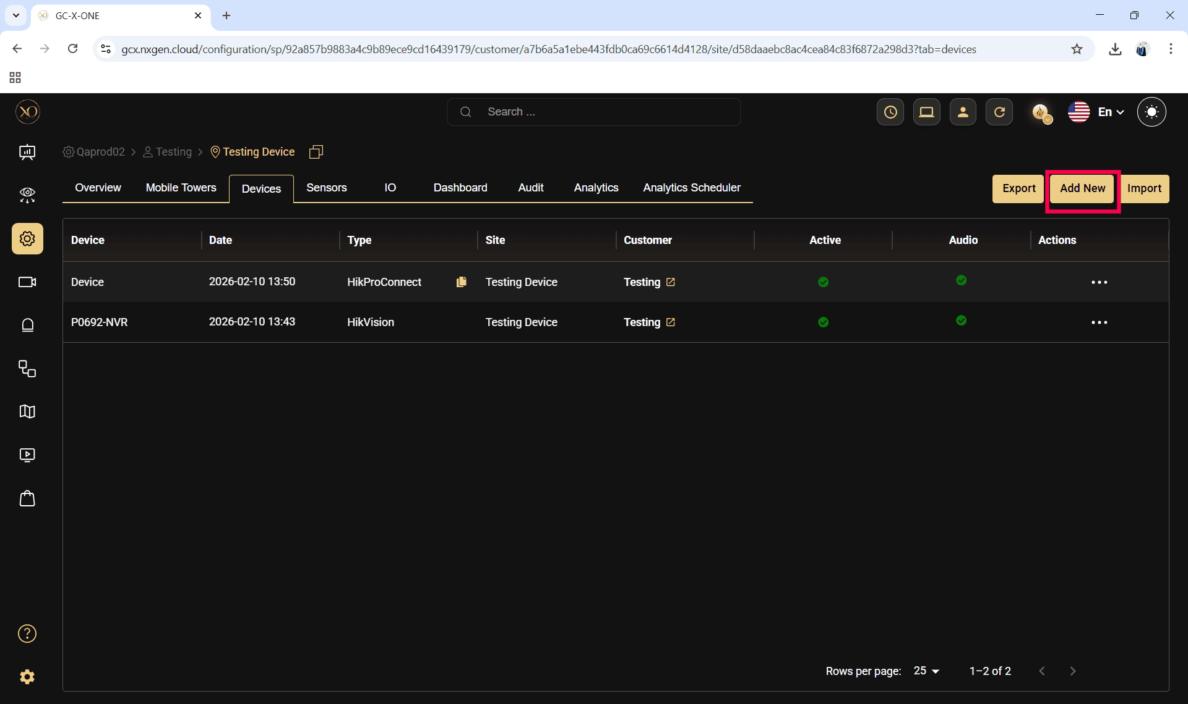

Step 13: The Add Device dialog will be displayed.
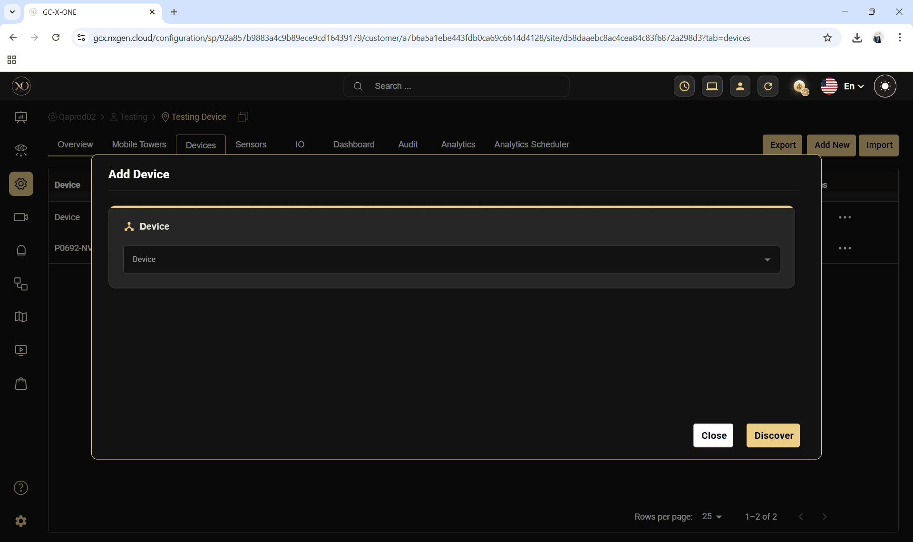

Step 14: In the dialog, open the Device dropdown and select Eagle Eye.

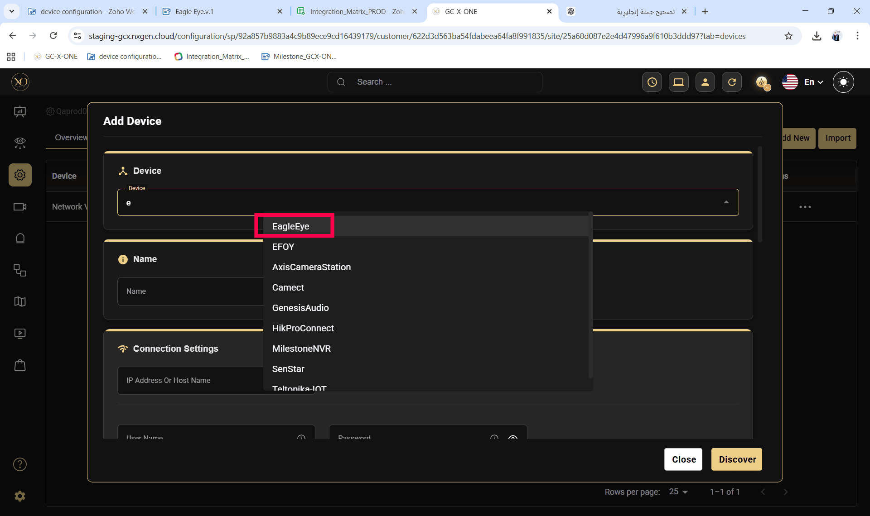
Step 15: Enter the required Eagle Eye identifiers
- name
- Serial No (ESN)
- user name / password

Step 16: Click Discover to initiate device validation and cloud handshake with Eagle Eye
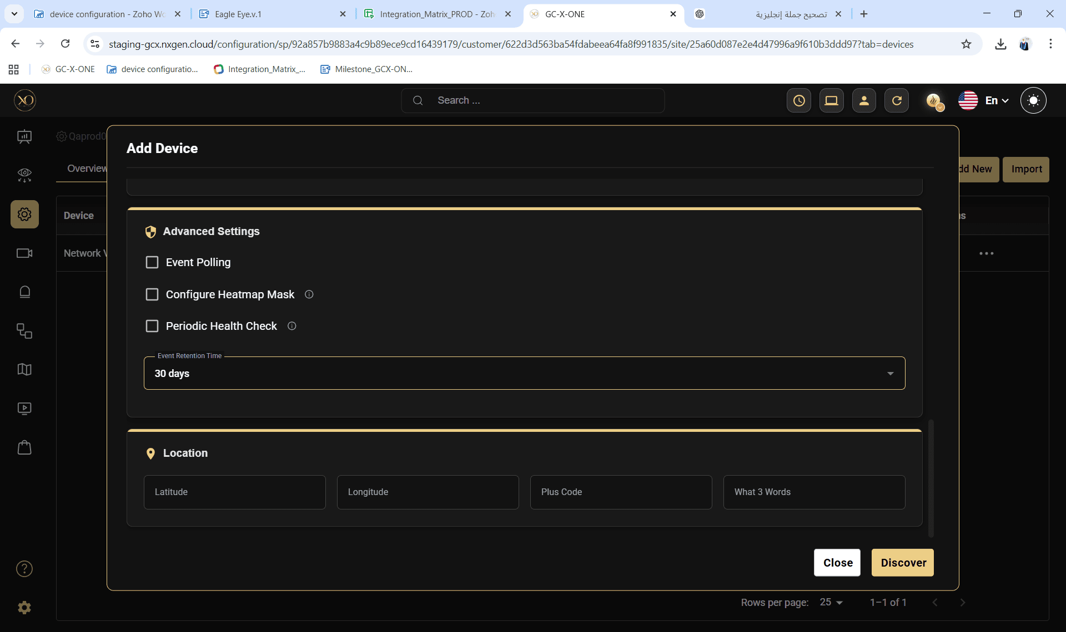
Step 17: Once the device is successfully discovered, click Save.
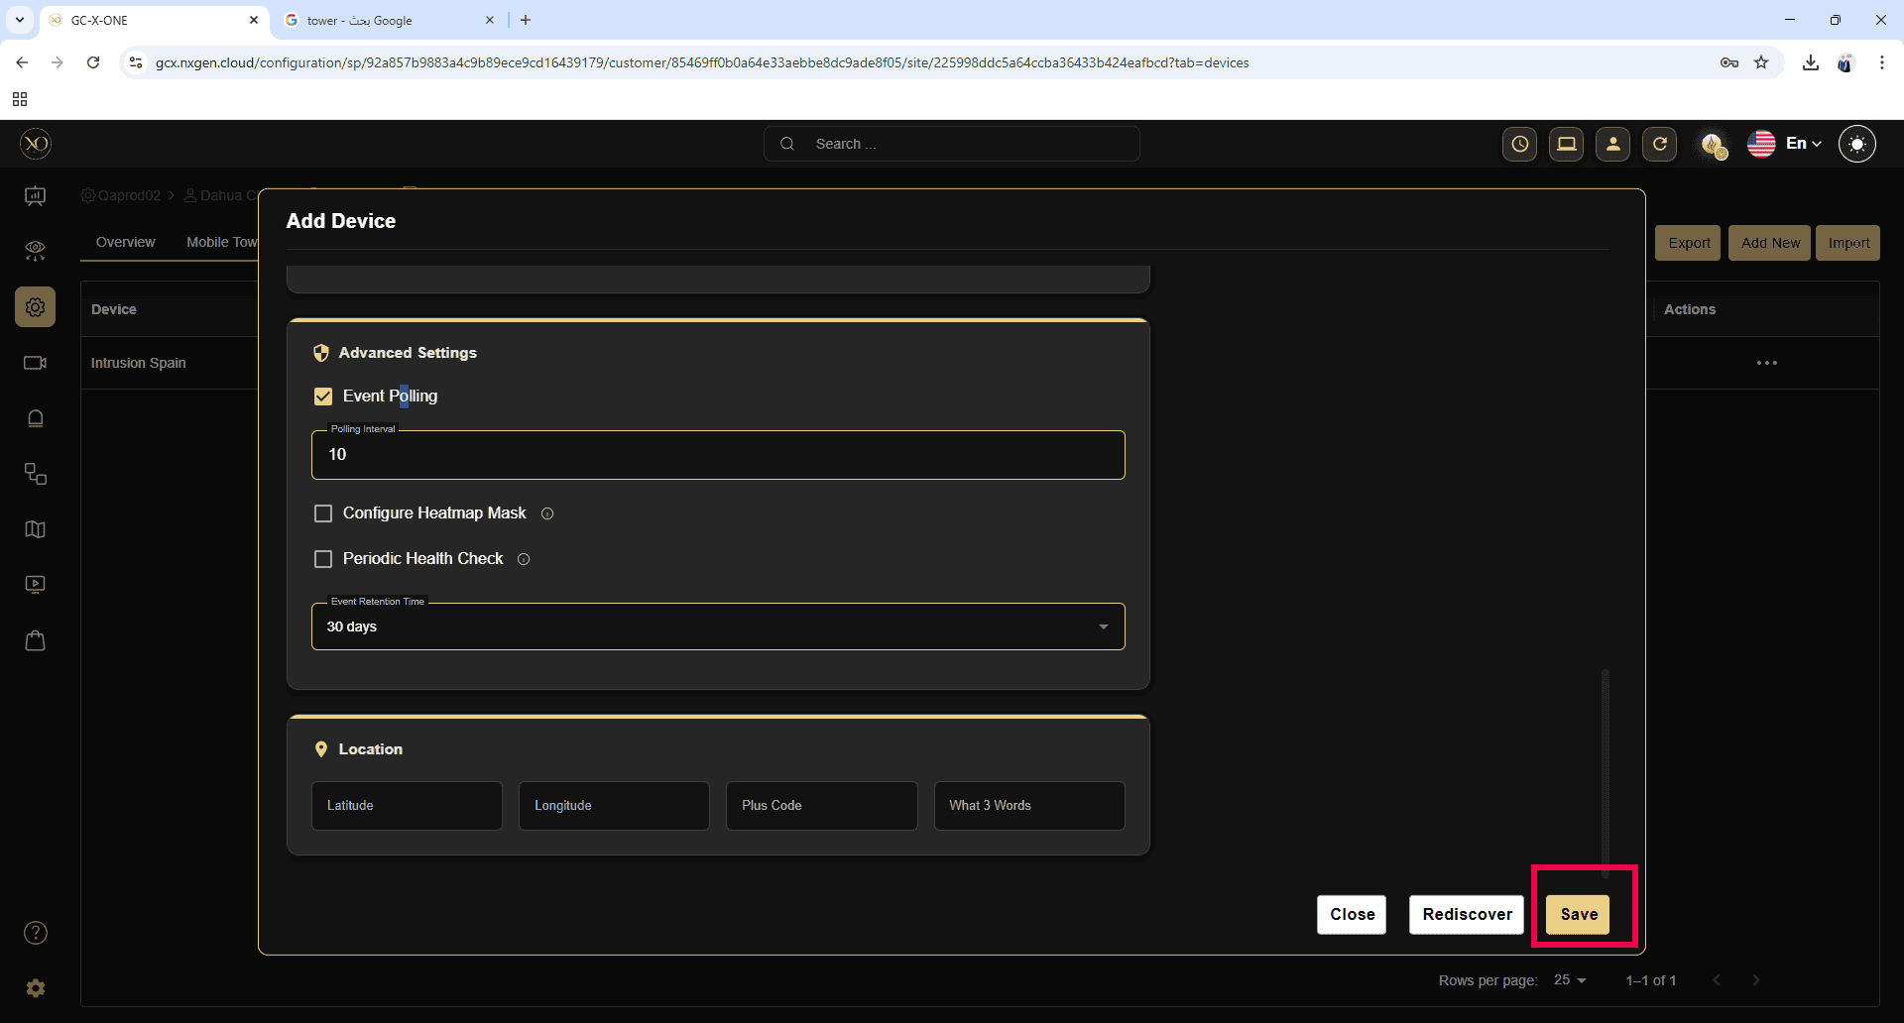

4. Post-Integration Validation
After successful onboarding, verify the following in GCX-ONE:
- Device status is Online
- Cameras are visible and correctly mapped
- Live stream is accessible
- Alarms are received properly (if the device is armed)

5. Common Integration Notes
- Discovery may fail if:
  - ESN is incorrect or not cloud-registered
  - The Bridge is offline
  - firewall blocks outbound connectivity
- One Eagle Eye Bridge can support multiple cameras; ensure bandwidth sizing aligns with camera resolution and frame rate.
- Camera naming consistency between Eagle Eye and GCX-ONE is recommended for operational clarity.

6. Support and Troubleshooting
If discovery or onboarding fails:
- Revalidate ESN and GUID in Eagle Eye Cloud
- Confirm WAN connectivity from the bridge
- Verify GCX-ONE user permissions
- Contact platform support and provide the bridge identifiers and site details

